https://medium.com/@nayabf52/covid-19-in-pakistan-dc55b28a58b6

COVID-19 In Pakistan(Data Visuallization)



Corona virus (Covid-19) is a newly discovered infectious disease. The COVID-19 outbreak was

first discovered in Wuhan, China, at the end of December 2019. Which has spread rapidly in

China and then all over the world in 209 countries.Pakistan is also one of those affected countries.The arrival of the virus in Pakistan was confirmed on February 26, 2020, when the student tested positive in Karachi after returning from Iran.By March 18, cases were registered in all four provinces, autonomous regions, and the Federal territory of Islamabad. These visuals aim to show the spread of corona virus in Pakistan.

**Data set:**

Dataset have been taken from<https://www.kaggle.com/mesumraza/corona-virus-pakistan-dataset-2020.It> consists of ten different data sheets and information related to growth of coronavirus in Pakistan.It contain various kind of data such as Local transmission,Foreign transmission,confirmed cases,total test performed,test positive cases,Home quarantine,no of deaths,discharged rate and recovery rate etc.

**Tool:**

Power bi is a customizable data visualization tool which enables us to visualize and analyze data with great speed and efficiency. There are three reasons for using this tool: Firstly It is flexible and easy to use for creating interactive visuals as it has a drag and drop interface. Secondly, this tool is compatible with multiple resources which include Microsoft Excel, SQL server etc. Thirdly, it allows us to share our visualization and publish them to our favorite blog or website in minutes.

**Data Cleaning:**

Power Bi has built in data cleaning tool named as transform data or Power query. I have used this tool to clean dataset of covid-19 for better analysis. Power query is a powerfull tool for transforming and cleaning data directly using the available library functions.Query editor let us clean our dataset by replacing values and errors and we can also drop columns and rename them.

**Visuallization:**

Local Transmission of Covid-19:

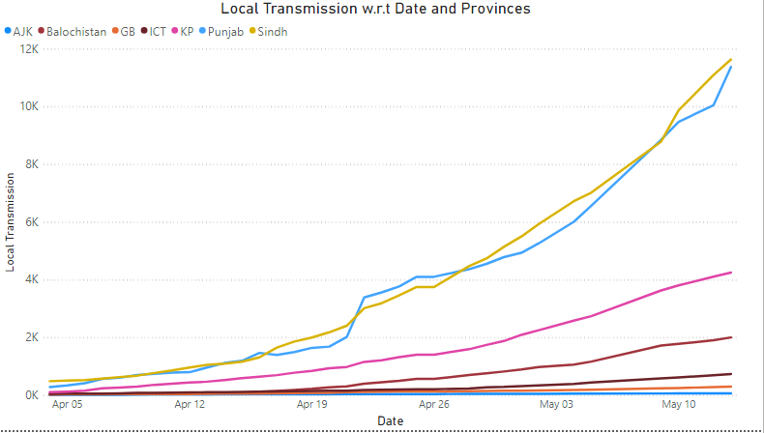

This graph shows the local transmission of corona virus in Pakistan.It has spread in all the the provinces with huge number of cases. We can see from the graph that local transmission of corona virus is increasing.On April 05,Punjab has 314 and Sindh has 514 locally transmitted cases. While if we look at the cases tranmissted locally on May 13,there is a great increase in cases: Punjab with 11380 figures ,Sindh with 11640 cases,kp with 4259 cases ,Balochistan with 2010 cases transmitted locally.While the other provines have lower cases transmitted local as compared to Punjab and Sindh.

**Confirmed Cases:**

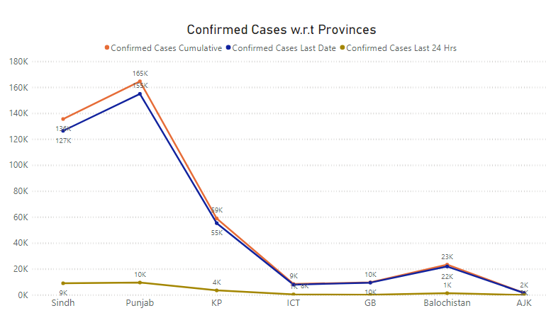

Punjab is leading with the 165k Confirmed cases followed by khyber paktunkhwa(kp) and Balochistan. Till now 135k cases have been confirmed in Sindh,59k in khyber paktunkhwa ,10k in Gilgit Baltistan,23k in Balochistan and 2k in Azad Jammu and Kashmir(AJK). 10 k cases have been confirmed in Punjab followed by Sindh with 9k confirmed cases during last 24 hours.

**Tests Performed:**

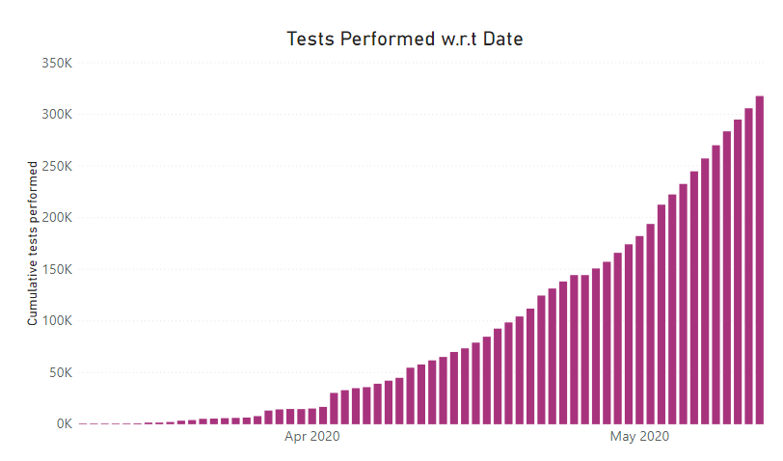

Graph shows that Pakistan has so far conducted 174160 on April 29 across the country.While 317699 corona tests was performed on May 12 in all the provinces.

**Commulative test positive:**

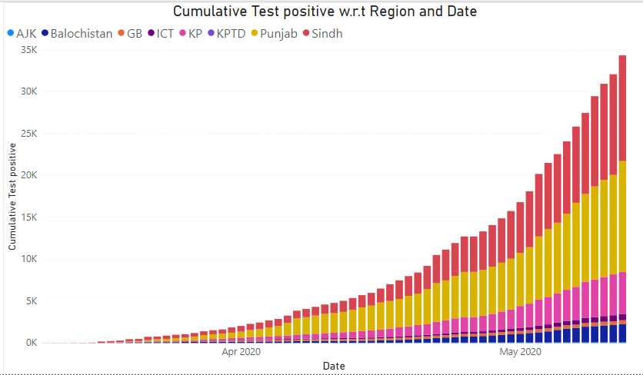

This graph shows that Punjab has highest rate of positive tests in Pakistan. In Punjab 13225 have tested positive followed by Sindh with 12610 patients, Balochistan with 2158 patients, 5025 in khyber paktunkhwa (KP) ,412 in Gilgit Baltistan have tested positive in on 12 May.

**Admitted Patients in different Provinces:**

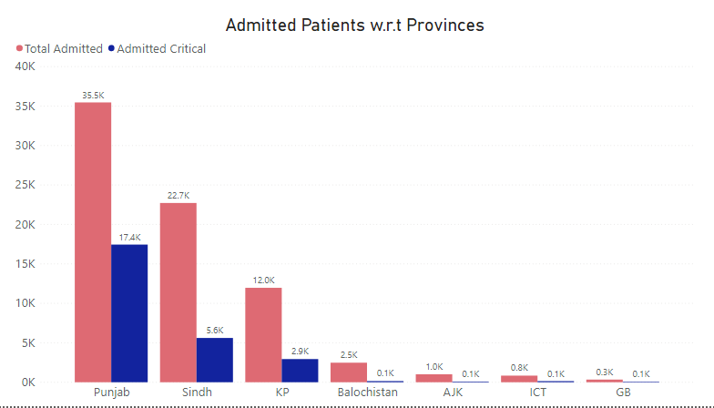

Since the corona virus has spread 35.5 k patients admitted in different hospitals working in Punjab with 17.4k patients in critical condition. Sindh have 22.7 k patients under treatment where 5.6k corona affecties in critical condition .Followed by khyber paktunkhwa with 12k admitted and 2.9k critically admitted patients ,Balochistan has 25k patients total admitted.There are no patients under critical condition in khyber paktunkhwa,Balochistan and Gilgit Baltistan.

**No of Patients recovered from coronavirus in Pakistan:**

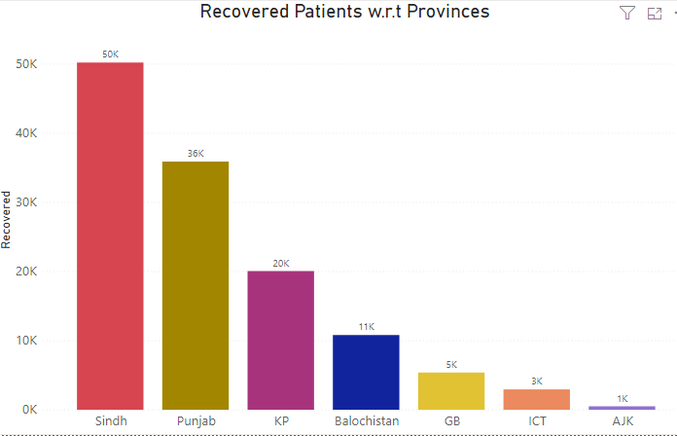

Till now, 50k patients have recoverd in Sindh,36k patients in Punjab and 20k in khyber paktunkhwa (kp) ,11k in Balochistan and 5k patients in Gilgit Baltistan and 1k patients have recoverd in Azad Jammu and Kashmir(AJK).

Discharged patients Vs Expired people w.r.t Region:

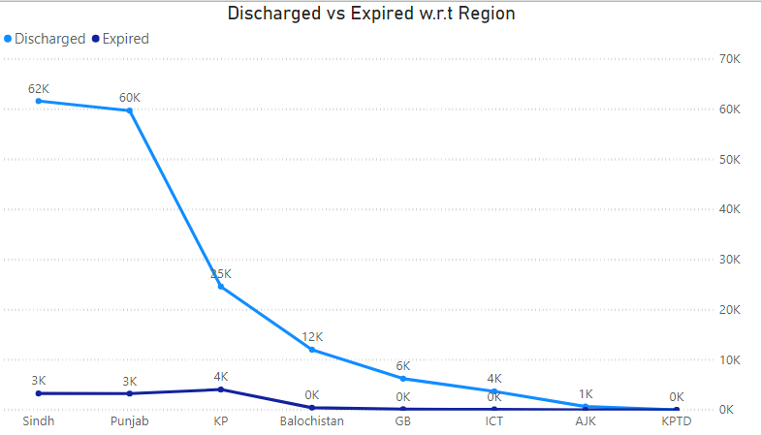

This graph shows the comparison between the patients discharged and the people who lost their lives due to covid-19 in all the provinces of Pakistan.Sindh has the highest number of patients discharged out of which 3k patients have lost their lives.Followed by Punjab with 60k discharged and 3k fatalities, and 4k Individuals have lost their live in epidemic in KP with 25k discharged patients and Balochistan with 12k discharged patients from hospitals.While Gilgit Baltistan(GB) with 6k ,ICT with 4K and AJK with 1k discharged patients.

**Quarantine Facilities provided by Provinces:**

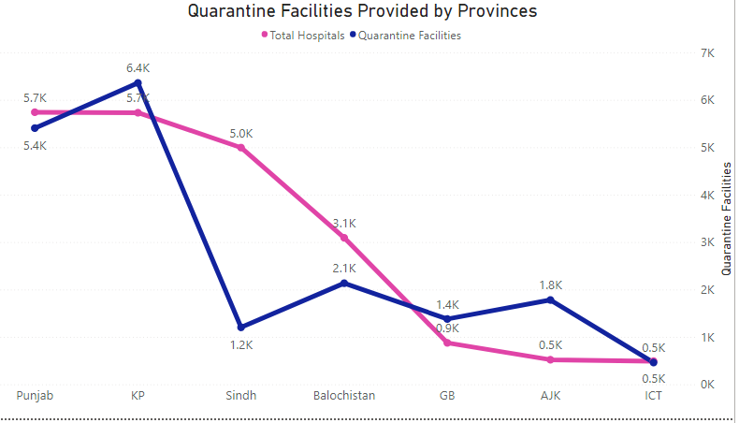

This graph is to compare the facilities provided by provinces in hospitals.Quarantine facilities have been established all acroos the country.Province wise breakdown:Kp has provided 6.4k quarantine facilities in 5.7k total hospitals.Followed by Punjab with 5.7k facilities in 5.4k hospitals,Balochistan with 2.1k facilities in 3.1k hospital,AJK with 1.8k facilities in nd 0.5k hospitals.While Sindh has provided 1.2k quarantine facilities in 5k different hospitals.

Home quarantined w.r.t Region:

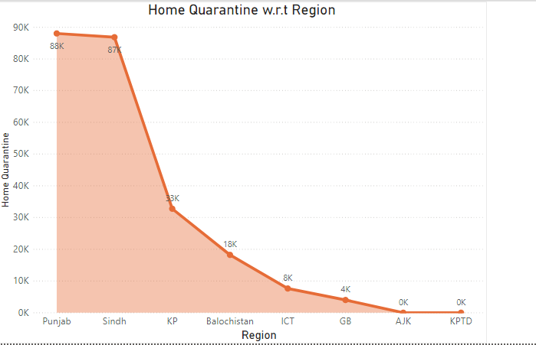

As we can see from the graph that Punjab have 88k people home quarantined followed by Sindh with 87k people home quarantined.33k in Khyber Pakhtunkhwa ,18k in Balochistan,8k in Islamabad capital territory,4k people are home quarantined in Gilgit Baltistan(GB).While Azad Jammu and Kashmir(AJK) have no people who are home quarantined.

**Suspected cases of coronavirus in Pakistan:**

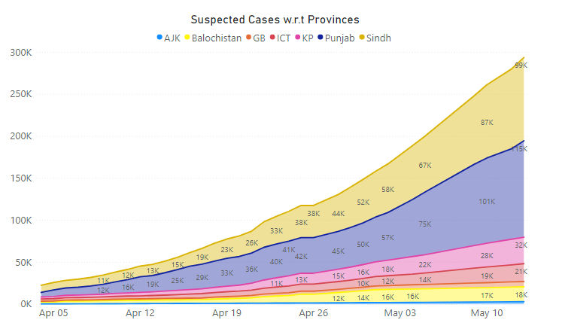

As we can see from the graph that how the suspected cases have increased from April 5 to May 10.On May 10,Suspected cases were reported in several provinces of Pakistan.Punjab’s suspected cases are 115k followed by Sindh with 99k cases , Khyber Paktunkhwa(kp) with 32k cases,Balochistan with 18k cases, Azad Jammu and Kashmir (AJK) with 3k+ cases and Islamabad Capital Terriotry(ICT) with 21K suspected cases.

**New cases registered in 24 hours:**

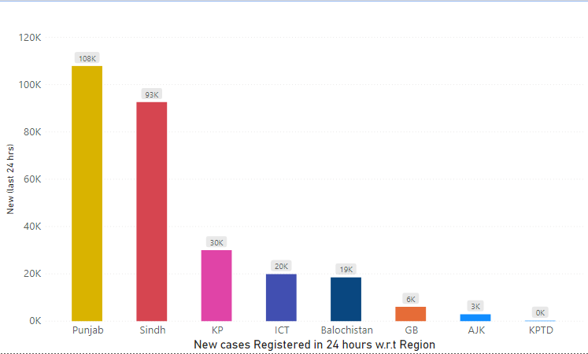

This graph shows that more than 100k cases have been registered in Punjab ,93k cases in Sindh,30k cases in khyber paktunkhwa(kp).While 20k cases in Islamabad Capital Terriotry(ICT),19K in Balochistan,6k in Gilgit Baltistan, and 3K fresh cases have been registered in Azad Jammu and Kashmir(AJK) during 24 hours.